Looking for Good Bugs in the Garden
PREDATOR | TALLY
LADYBUGS
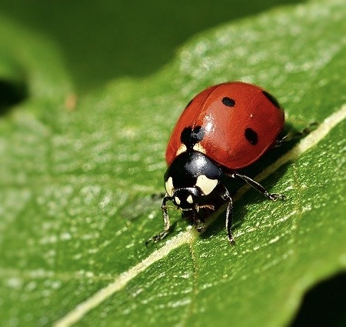

LACEWINGS
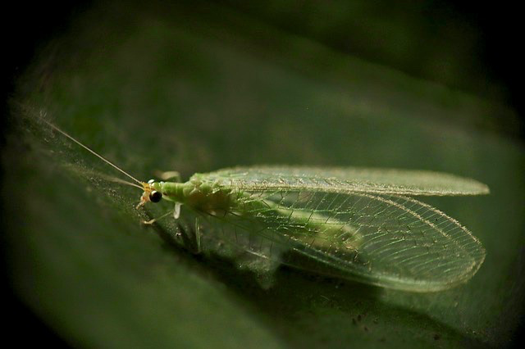
DRAGONFLIES
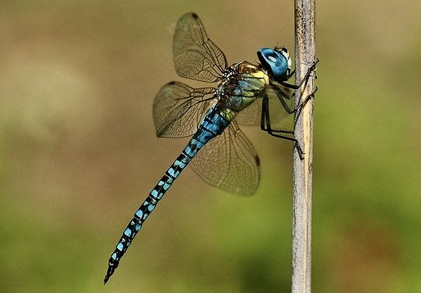
PRAYING MANTIS
